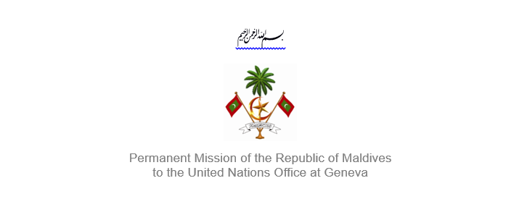
25th Session of the Working Group of the Universal Periodic Review
2 – 13 May 2016, Geneva

Review of Suriname
2 May 2016

Statement delivery by
Her Excellency Dr. Hala Hameed, Ambassador / Permanent Representative
of Maldives to the United Nations Office at Geneva

Check against delivery

Thank you, Mr. President,

The Maldives extends a warm welcome to the high level delegation from Suriname to this review, led by H.E. Mrs Jennifer van Dijk-Silos, Minister of Justice and Police. The Maldives expresses its appreciation for today’s presentation, and takes note of the national report, and implementation of the recommendations Suriname received during its first cycle.

The Maldives commends Suriname for its accession to the Convention on the Rights of Persons with Disabilities in September 2015. We also commend efforts made within anti-discrimination initiatives in the country, noting the implementation of various awareness raising campaigns to promote gender equality and public participation.

The Maldives appreciates the measures taken by Suriname to support mental health in the country, including the most recent Policy Plan Mental Health 2015-2017. We also take positive note of the implementation of a housing plan for the period of 2012-2017. The right to adequate housing is an imperative component of development and we appreciate the constructive actions of the State in this regard.

Further, the Maldives would like to make the following recommendations:

1) Improve access to primary and secondary education for all children, including those with disabilities

2) Implement programmes to empower women’s participation in the work force and in political sphere.

My delegation wishes the delegation of Suriname all the success during this review.

Thank you Mr. President.

